Institute of Computer Technology

B. Tech Computer Science and Engineering

Subject: Basics Of Communication Systems (2CSE202)

**PRACTICAL-4**

**AIM: - To create Local Area Network**

**QUESTION 1:**

**Jack wanted to setup a network for his office. The devices in the network must be capable of communicating with each other. So first, he needs to prepare a plan to implement the same. Guide Jack with the plan as well as with the setup of the network.**

**Steps:**

**Step 1:** Connect devices to switch hub or router through RJ 45 Ethernet cable.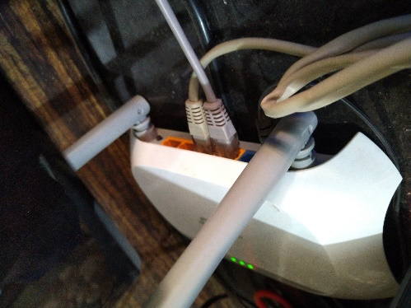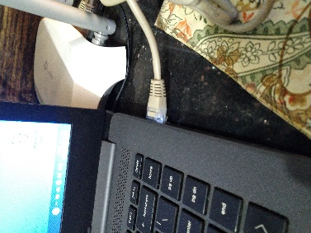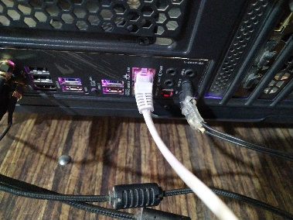

**Step 2:** After setting up network fire a ping command to check the connectivity if your devices

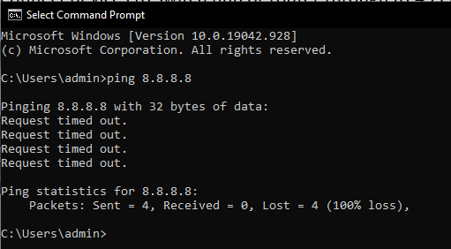

**Step 3:** then check that you are also reachable to connected device also go to the control panel and change settings (turn of defenders)

**Step 4:** now go to network settings and change ipv4 /TCP and give private ip to the network:

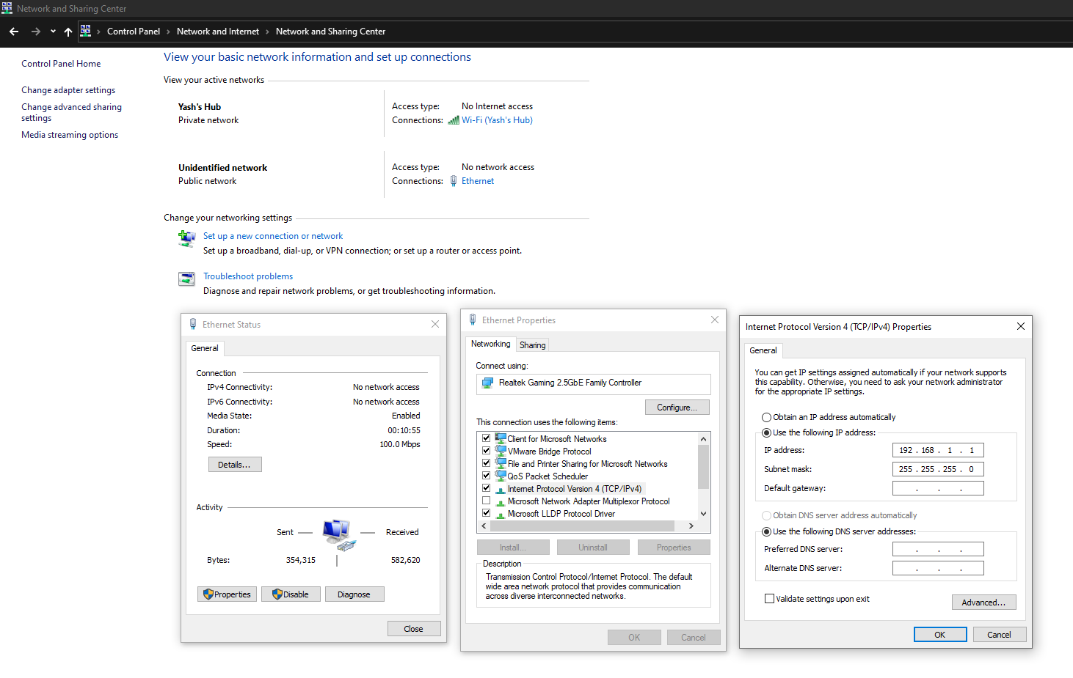

**Step 5:** here I have taken 192.168.1.1 ip for my device and another ip 192.168.1.2 for another device. That’s how jack needs to built the network but before sharing file get assure that whether you are connected to another device fire ping command and check

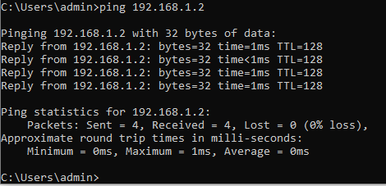

**QUESTION 2:**

**The head office of Mango organization has only 2 devices and Jack only wanted to connect both the device through each other, so that they can share the document which each other while working on the same project. Guide Jack to do the same.**

**Step 1:** connect devices to switch hub or router through RJ 45 Ethernet cable.



**Step 2:** After setting up network fire ping command to check the connectivity of your devices

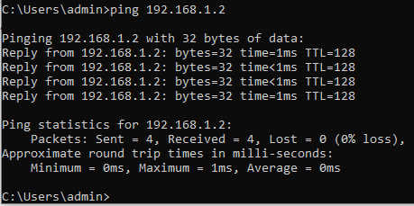

**Step 2:** After setting up network fire a ping command to check the connectivity if your devices



**Step 3:** then check that you are also reachable to connected device also go to the control panel and change settings (turn of defenders)

**Step 4:** now go to network settings and change ipv4 /TCP and give private ip to the network:



**Step 5:** here I have taken 192.168.1.1 ip for my device and another ip 192.168.1.2 for another device. That’s how jack needs to built the network but before sharing file get assure that whether you are connected to another device fire ping command and check

**Step 6:** now for sharing data go to Desktop and follow this select any particular file and right click on it.

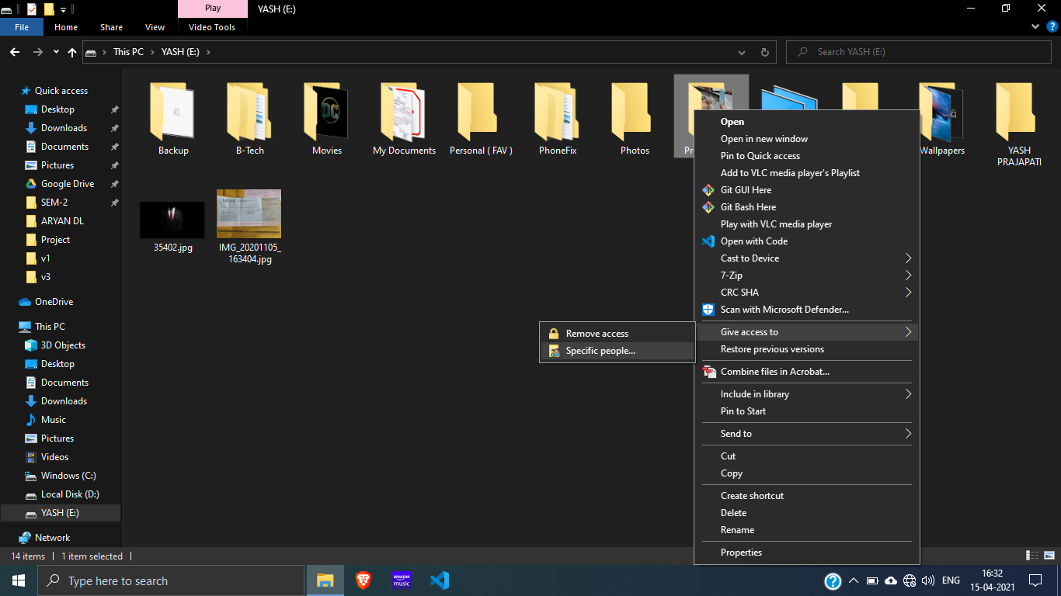

**Step 7:** now give access to everyone and share data

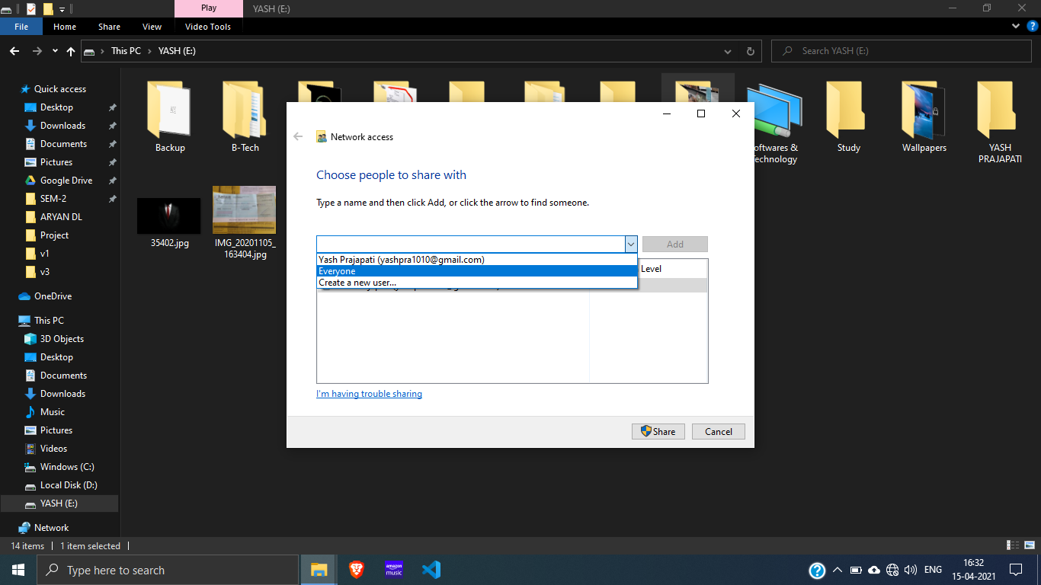

**Step 8:** finally, after sending file it will show done

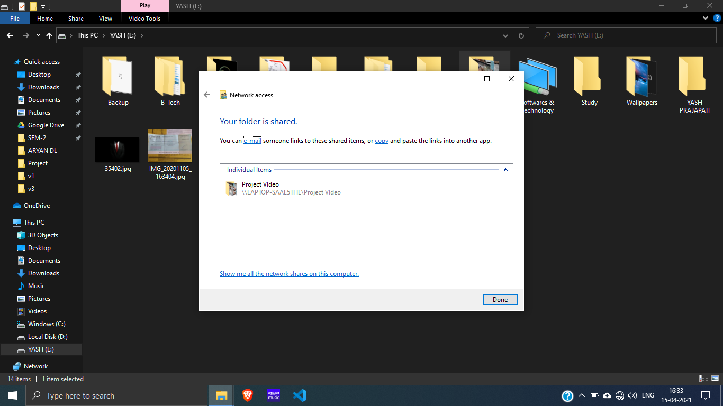

Now check it in another device simply switch on to another device and go to run and type the ip address of device from u want to have data

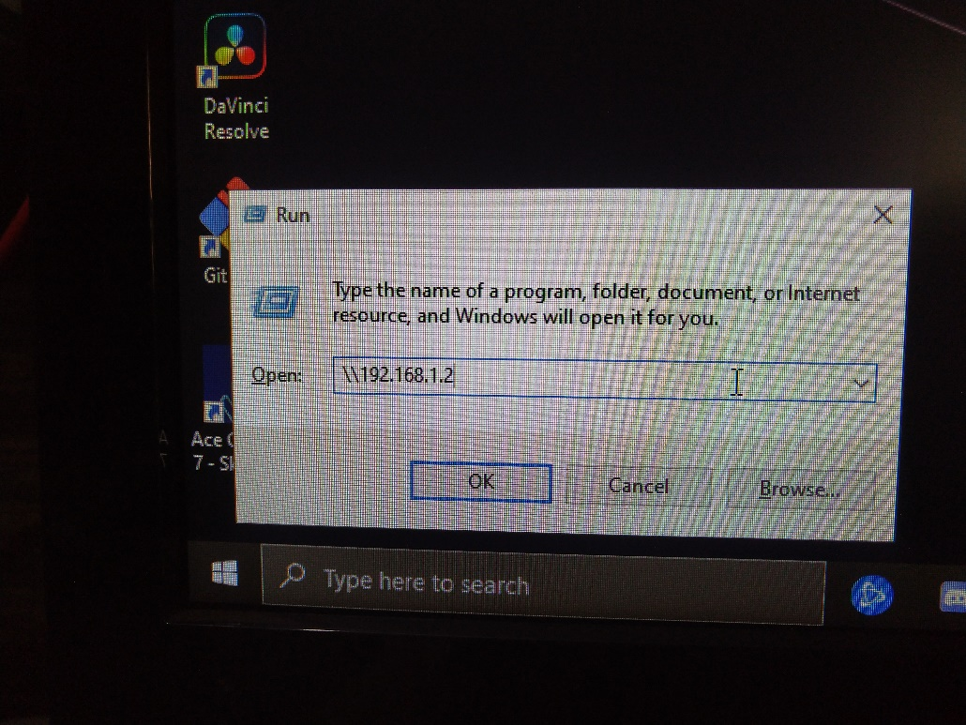

So finally, u can see the file from 1 device to another device

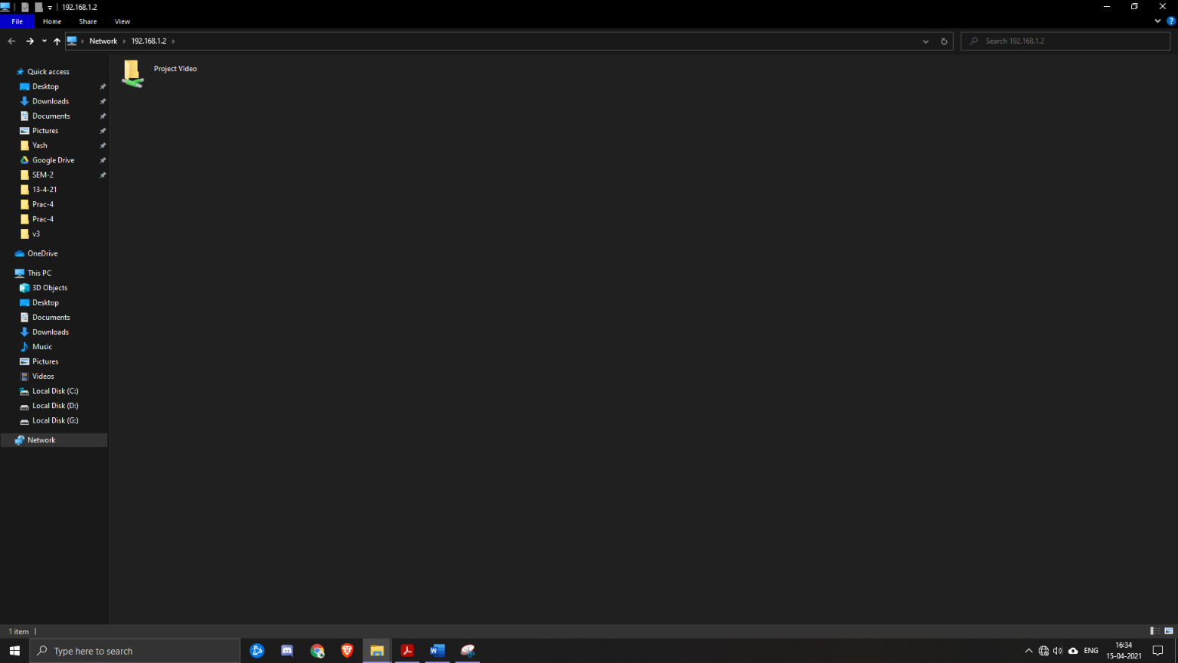

**Conclusion:**

Here, by doing this practical we conclude the creation and working of Local Area Network (LAN) network.